**Project Batch ID 85**

|  |  |  |  |  |
| --- | --- | --- | --- | --- |
| **Name of student** | **Register Number** | **Department** | **Mobile Number** | **Email ID** |
| Jayesh Poonia | RA2111030010261 | NWC | 8529480740 | [jp0102@srmist.edu.in](mailto:jp0102@srmist.edu.in) |
| Vedika Singh | RA2111030010295 | NWC | 8454892164 | vt3264@srmist.edu.in |

|  |  |  |  |  |  |  |  |
| --- | --- | --- | --- | --- | --- | --- | --- |
| **Working Title of the Project:** | | | **AI-Powered Sustainable Agriculture** | | | | |
| **Project Site / Location** | | | SRM IST, Kattankulathur, Chengalpattu District-603203 | | | | |
| **Name and address of the company / organization (Applicable for projects with industry or industry support)** | | | SRM IST, Kattankulathur, Chengalpattu District-603203 | | | | |
| **Supervision Team** | | | | | | | |
|  | **Supervisor** | | | | **Co-Supervisor** | | **External Supervisor (If applicable)** |
| **Name** | Dr D Saisanthiya | | | | **-** | |  |
| **Designation** | Assistant Professor | | | | **-** | |  |
| **Department** | Networking and Communications | | | | **-** | |  |
| **Campus** | Kattankulathur | | | | **-** | |  |
| **Telephone** |  | | | | **-** | |  |
| **E-mail** |  | | | | **-** | |  |
| **Degree/**  **program** | | B. Tech | | **Specialization** | | Computer Science & Engineering with specialization cyber security | |

|  |  |  |  |
| --- | --- | --- | --- |
| **Academic Year** | 2024-2025 (Even) | **Semester** | 8 |
| **Course Code** | **18CSP109L** | **Course Title** | Project |

# Mission Statement

To revolutionize sustainable agriculture through an AI-powered platform that integrates plant disease detection, personalized crop recommendations, and a multilingual chatbot—enabling farmers to make informed decisions using accessible technology, thereby increasing productivity, resilience, and environmental harmony.

|  |
| --- |
| **Problem (or) Product Description:** |
| A unified smart agriculture system that leverages machine learning and natural language processing to deliver personalized assistance in disease detection, crop selection, and fertilizer usage. The platform includes a ResNet9-based plant disease classifier, a chatbot with an HHH filtering layer for intelligent support, and a crop recommendation model using Random Forest, trained on soil and environmental parameters. |
| **Assumptions and Constraints** |
| **Assumptions**   * Farmers own smartphones or internet-enabled devices. * Users interact with the system in their native language. * Quality datasets (disease, soil, crop yield) are accessible. * External APIs for soil and weather data are available. * Users are open to digital interventions in farming.   **Constraints**   * Rural connectivity may limit real-time performance. * Diverse dialects may challenge chatbot accuracy. * Image datasets may suffer from class imbalance. * Edge devices limit model complexity and response time. * Data privacy and ethical usage rules must be respected. |

**Division of work and contributors of SPRINT 1 [ Include Daily Scrum of Sprint 1]**

# Objectives of User Stories of Sprint 1

* Collect datasets (crop, soil, weather, disease).
* Clean and standardize data formats.
* Annotate disease images.
* Store data securely for model training.

# Functional Document

1. **Member 1: Jayesh Poonia**

* Source data from government and open repositories (KVK, FAO, Kaggle).
* Preprocess: handle nulls, standardize units, normalize values.
* Merge datasets on state, month, crop, and soil type.
* Structure the data schema for downstream ML models.

# Member 2: Vedika Singh

* Set up environment and dependencies (e.g., TensorFlow, OpenCV).
* Annotate plant disease images and apply bounding boxes.
* Conduct basic object detection tests.
* Prepare ResNet9 data input pipeline.

# Outcome of Objectives / Result Analysis

* Datasets organized, merged, and annotated.
* System environment and tools validated.
* Roles clearly divided and timeline aligned

# Sprint Retrospective

* Team synergy and task clarity ensured momentum.
* Frequent scrums reduced blockers.
* Ready for transition into model training and integration.

**Signature of the Supervisor**

**Division of work and contributors of SPRINT 2 [ Include Daily Scrum of SPRINT 2]**

# Objectives of User Stories of Sprint 2

* + Train disease detection and crop recommendation models.
  + Evaluate models with validation data.
  + Deploy models via Fast API for integration.

# Functional Document

**Member 1: Jayesh Poonia**

* + Train ResNet9 on annotated disease dataset.
  + Train Random Forest model for crop recommendation using NPK, pH, etc.
  + Tune hyperparameters and store models (.pkl/.h5).  
    .

**Member 2: Vedika Singh**

* + Evaluate models (accuracy, precision, recall).
  + Export models and prepare endpoints using FastAPI.
  + Implement logic for HHH-filter-based chatbot response routing..

# Outcome of Objectives / Result Analysis

* ResNet9 and Random Forest models show promising performance.
* Models successfully deployed with FastAPI backend.
* Chatbot logic supports dynamic crop/farming queries..

# Sprint Retrospective

* Objectives completed as planned.
* Faced minor issues with image imbalance.
* Cross-validation improved reliability.

**Signature of the Supervisor**

**Division of work and contributors of SPRINT 3 [ Include Daily Scrum of Sprint 3]**

# Objectives of User Stories of Sprint 3

* Integrate external APIs (weather, soil).
* Enhance chatbot logic and context management.
* Conduct system-wide functional testing.

# Functional Document Member 1: Jayesh Poonia

* Integrate OpenWeatherMap and soil APIs based on user GPS.
* Develop rule-based mapping in chatbot for recommendations.
* Add fallback handling for API failures or empty responses.

# Member 2: Vedika Singh

# Define model performance metrics and test with unseen inputs.

# Measure latency and evaluate system on edge constraints.

# Conduct system testing from UI → API → Model response.

# Outcome of Objectives / Result Analysis

* APIs integrated and functioning reliably.
* Chatbot context awareness and suggestions improved.
* End-to-end tests validate prediction workflows.

# Sprint Retrospective

* Good progress with integration and responsiveness.
* Minor lag observed under simultaneous model queries.
* Testing improved system robustness for field deployment.

**Signature of the Supervisor**

**Worksheet / Data collection:**

**For Plant Disease Detection**

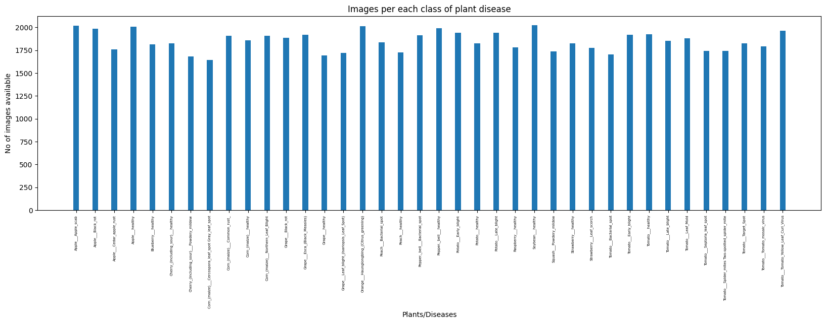

|  |  |
| --- | --- |
| **Apple___Apple_scab** | **2016** |
| **Apple___Black_rot** | **1987** |
| **Apple___Cedar_apple_rust** | **1760** |
| **Apple___healthy** | **2008** |
| **Blueberry___healthy** | **1816** |
| **Cherry_(including_sour)___healthy** | **1826** |
| **Cherry_(including_sour)___Powdery_mildew** | **1683** |
| **Corn_(maize)___Cercospora_leaf_spot Gray_leaf_spot** | **1642** |
| **Corn_(maize)___Common_rust_** | **1907** |
| **Corn_(maize)___healthy** | **1859** |
| **Corn_(maize)___Northern_Leaf_Blight** | **1908** |
| **Grape___Black_rot** | **1888** |
| **Grape___Esca_(Black_Measles)** | **1920** |
| **Grape___healthy** | **1692** |
| **Grape___Leaf_blight_(Isariopsis_Leaf_Spot)** | **1722** |
| **Orange___Haunglongbing_(Citrus_greening)** | **2010** |
| **Peach___Bacterial_spot** | **1838** |
| **Peach___healthy** | **1728** |
| **Pepper,_bell___Bacterial_spot** | **1913** |
| **Pepper,_bell___healthy** | **1988** |
| **Potato___Early_blight** | **1939** |
| **Potato___healthy** | **1824** |
| **Potato___Late_blight** | **1939** |
| **Raspberry___healthy** | **1781** |
| **Soybean___healthy** | **2022** |
| **Squash___Powdery_mildew** | **1736** |
| **Strawberry___healthy** | **1824** |
| **Strawberry___Leaf_scorch** | **1774** |
| **Tomato___Bacterial_spot** | **1702** |
| **Tomato___Early_blight** | **1920** |
| **Tomato___healthy** | **1926** |
| **Tomato___Late_blight** | **1851** |
| **Tomato___Leaf_Mold** | **1882** |
| **Tomato___Septoria_leaf_spot** | **1745** |
| **Tomato___Spider_mites Two-spotted_spider_mite** | **1741** |
| **Tomato___Target_Spot** | **1827** |
| **Tomato___Tomato_mosaic_virus** | **1790** |
| **Tomato___Tomato_Yellow_Leaf_Curl_Virus** | **1961** |

**For Crop Recommendation**

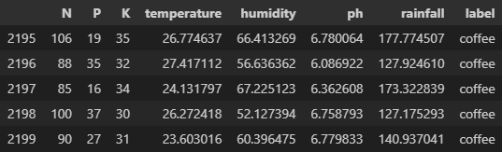

# Research Article with Journal Publication Details / Patent disclosure form with patent status

(include certificates and proofs)

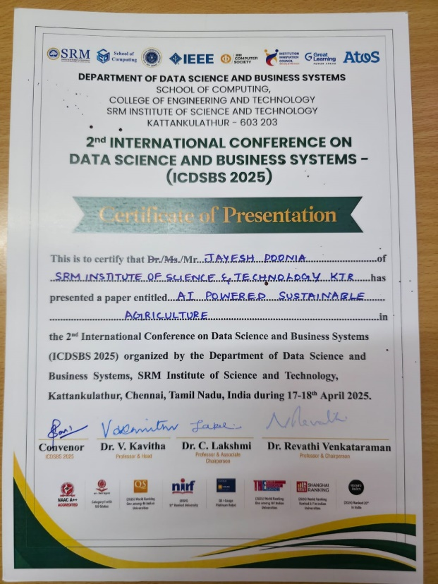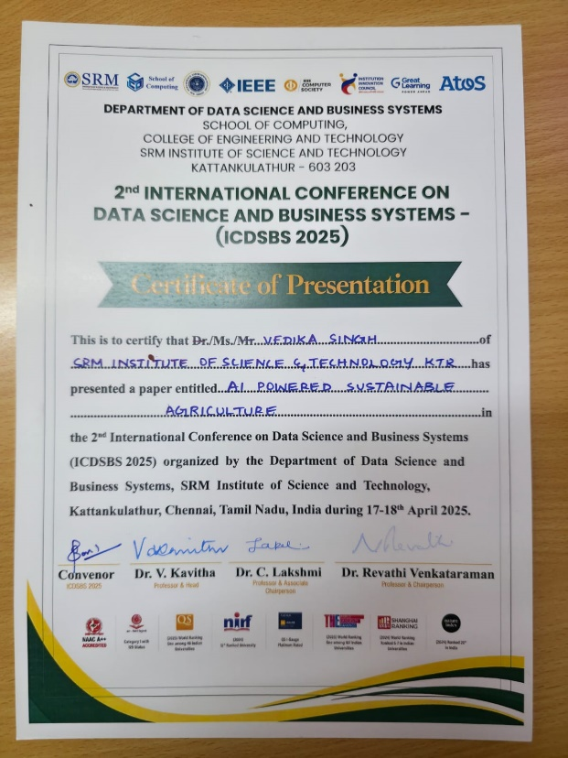

We have submitted our research paper titled “AI-Powered Sustainable Agriculture” for journal publication following its acceptance and presentation at 2025 2nd International Conference on Data Science and Business Systems (ICDSBS 2025) held at SRM Institute of Science and Technology.

The manuscript is currently under review with the journal associated with the conference, and we have confirmation of its acceptance and presented there for the upcoming issue. We anticipate receiving a formal update from the editorial committee soon.